* **NESTED WHILE LOOP :-**
* **Print multiplication table using nested while loop.**

i=1  
while(i<=10):  
 j=1  
 while (j <= 10):  
 print(i*j,end= " ")  
 j += 1  
 i+=1  
 print("\n")

* **OUTPUT:**

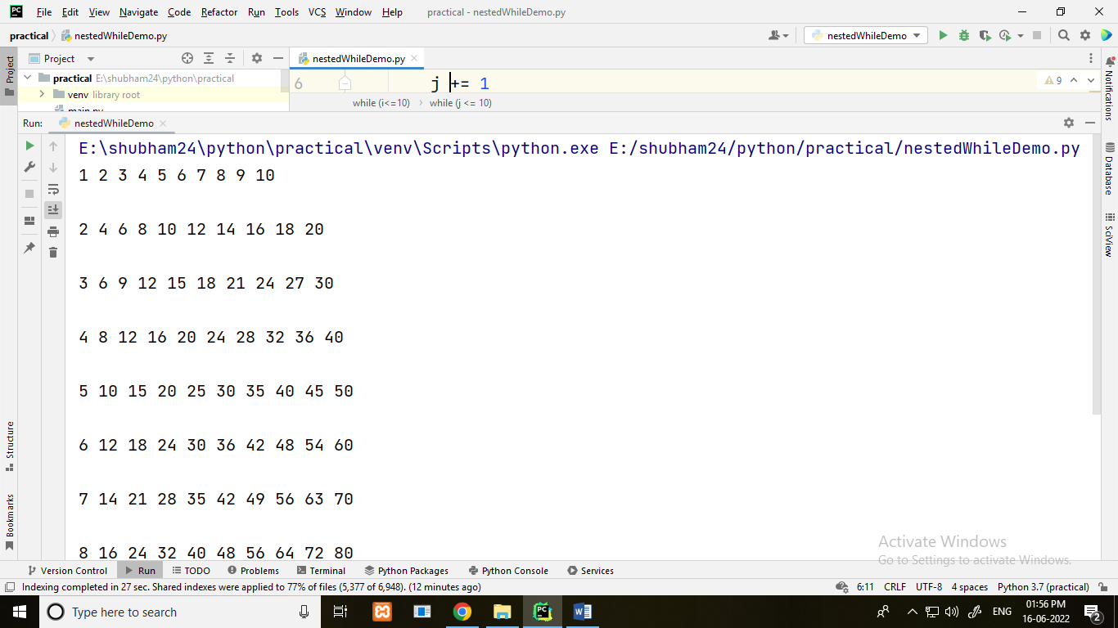

* **Print prime number upto 20(given number) using nested while loop**

i=2  
while(i<20):  
 j=2  
 while(j<=(i/j)):  
 if not(i%j):  
 break  
 j+=1  
 if(j>i/j):  
 print(i, "is prime number")  
 i+=1

* **OUTPUT:**

